The homework is to finish a program that I started. The program will sort two identical arrays, each one in its own thread. One thread will sort using the built in .NET Array.Sort method, the other will sort using a BubbleSort that you have to code.

Open my starter project and review my comments carefully, they explain what code you need to write and where. The time it takes each thread to complete their sort might depend on which one gets started first, so run the program twice, changing which sort thread you start first. Record the results for both runs and submit that data as a comment when you submit your zipped project. (screen shots are not required).

As the comments indicate, when you think the code is working, uncomment the last line of each thread that writes out the array to make sure it really did sort the array.

This is what the two runs of my program looks like:

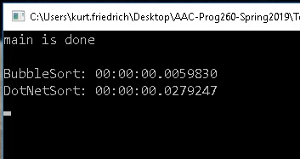

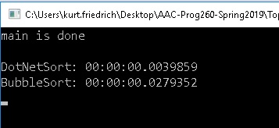

What does this say about which sort is the fastest?